**MSc in Data Analytics (SB+) - Sept 2023 - 2024 - YR1**

Author: Jose Maria Rico Leal

e-mail: sba23021@student.cct.ie

Student ID: sba23021

GitHub Link:

ca2 twitter dataset big data and data visualization

## **Abstract**

*This report focuses on processing and analysing a Twitter dataset, to process the data technologies like Hadoop, MapReduce, MySQL, Cassandra are demonstrated also an exhaustive database performance analysis is performed using Yahoo Cloud Serving Benchmark. To analyse the dataset a neural network using time series is applied to detect and predict any sentiment change throughout the given period….*

**Abstract** 1

**1.** **Introduction** 3

**2.** **Big Data** 3

2.1. Data storage and processing activities 3

2.1.1. Storing *ProjectTweets.csv* in HDFS 4

2.1.2. *MapReduce* jobs 4

2.1.2.1. Count and display mentions and hashtags 4

2.1.2.2. Distinct *tweet_Id* count 5

2.1.2.3. Cleaning tweets removing commas and quotes 7

2.1.2.4. Ordering dataset based on *ids* 7

2.1.3. Spark 9

2.1.4. Hive 9

2.1.5. *MySQL* 10

2.1.6. Cassandra 11

2.2. Database comparison for *Cassandra, MySQL* and *MongoDB* using YCSB. 11

2.2.1. Workload A: Update heavy 12

2.2.2. Workload B: Read mostly 12

2.2.3. Workload C: Ready only 12

2.2.4. Workload D: Read latest 12

2.2.5. Workload E: Short ranges 12

2.2.6. Workload F: Read-modify-write 12

2.2.7. Workload G: Write only 12

2.2.8. Rows load: inserts 12

2.3. Rationale and justification for data processing, storage, and programming language 12

2.4. Big Data diagram 12

**3.** **Advanced Data Analytics** 12

3.1. DA 12

**4.** **Conclusion** 12

**5.** **References** 12

**6.** **Annex** 13

6.1. Big Data 13

6.1.1. Storing *ProjectTweets.csv* in HDFS 13

6.1.2. *MapReduce* count and display mentions and hashtags 14

6.1.3. *MapReduce* distinct *tweet_id* count 16

6.1.4. *MapReduce* cleaning tweets removing commas and quotes 16

6.1.5. *MapReduce* ordering dataset based on *ids* 17

6.1.6. *Spark* 19

6.1.7. *Hive* 19

6.1.8. *MySQL* 21

6.1.9. *Cassandra* 22

6.1.10. *YCSB: MySQL* 23

6.1.11. *YCSB: MongoDB* 28

6.1.12. *YCSB: Cassandra* 32

# **Introduction**

This project is divided in two sections Big Data and Advanced Data Analytics.

For Big Data a csv file is processed using Hadoop, from there *MapReduce* is applied to perform four tasks. Reading data from Hadoop is achieved using Spark for streaming and Hive for badging. As a non *HDFS* databases *MySQL* and Cassandra are also explored to finalise this section a thorough analysis for MySQL, Cassandra and MongoDB is carried out using Yahoo Cloud Serving Benchmark (YCSB).

The second section Advanced Data Analytics….

# **Big Data**

# Data storage and processing activities

According to Manwal and Gupta (2017), large organizations such as *Twitter, Facebook*, and *LinkedIn* use Hadoop to handle the vast amounts of data they generate daily. As the starting point of this project is the dataset *ProjectTweets.csv*, it would be beneficial to emulate the data processing methods used in *Twitter* analytics department.

# Storing *ProjectTweets.csv* in HDFS

Full implementation of this step can be seen at the annex section 6.1.1, the relevant part is that file now is into Hadoop and from there *MapReduce* jobs can be deployed, data can be read using Hive and data can be streamed for the analytics part using Spark.

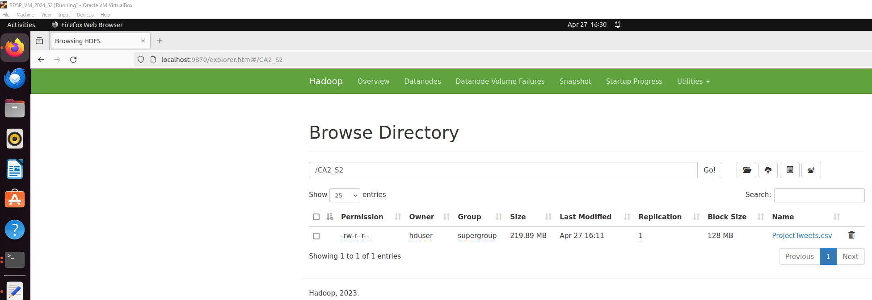  
Fig. 1. *ProjectTweets.csv* stored into Hadoop.

# *MapReduce* jobs

Four different *MapReduce* jobs have been implemented with the aim of demonstrating how to perform these tasks. These jobs were also necessary to identify duplicates within ProjectTweets.csv, to clean the dataset before importing it into *Cassandra* and *MySQL* (as the last column contains commas and quotes, which are incompatible with those databases), and to demonstrate that Hive can achieve the same outcomes as a *MapReduce* job. Please note that full *MapReduce* jobs implementation can be found in the annex sections 6.1.2, 6.1.3, 6.1.4 and 6.1.5.

# Count and display mentions and hashtags

A given task could be to count all mentions and hashtags contained in this file. The mapper processes tweet text to find hashtags and mentions and then emits them as intermediate key-value pairs where the keys are the entities with a prefix, values are all 1 indicating a single occurrence for each entity.

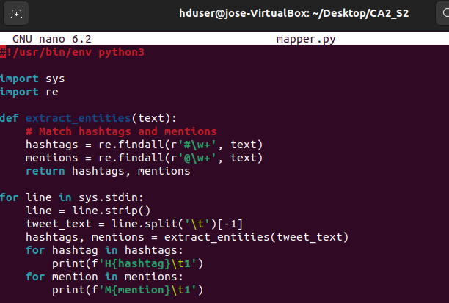  
Fig. 2. *mapper.py*

The reducer sums above calculated occurrences to get a count of how often each hashtag and mention appears.

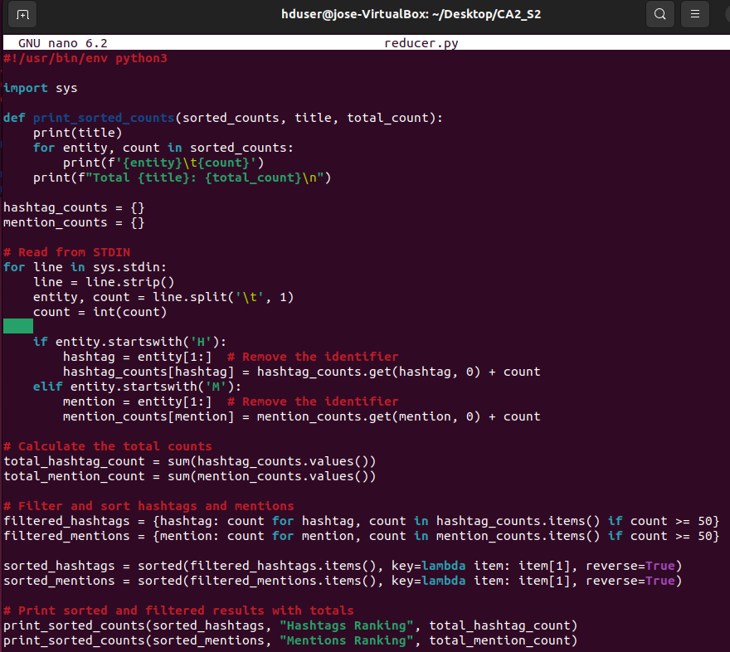  
Fig. 3. *reducer.py*

# Distinct *tweet_Id* count

This *MapReduce* job is paired with a Hive query that will produce the same output, counting distinct values for *tweet_id*. This mapper outputs each *tweet_id* it encounters as a key-value pair, with the *tweet_id* as the key and 1 as the value.

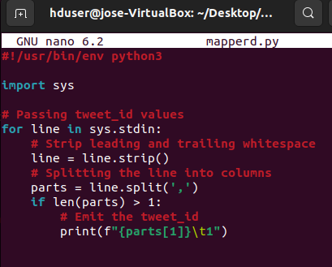  
Fig. 4. *mapperd.py*

The reducer counts unique *tweet_id* values received from the mapper.

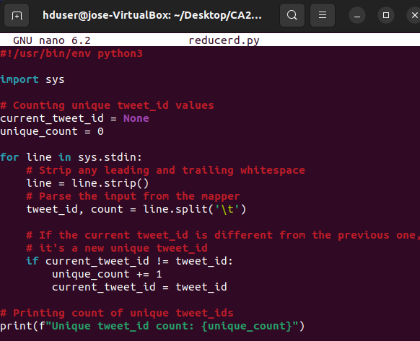  
Fig. 5. *reducerd.py*

Result to be compared with Hive query, from 1,600,000 rows, 1,598,315 are unique *tweet_id*.

  
Fig. 6. distinct *tweet­_id* count

# Cleaning tweets removing commas and quotes

After several attempts to insert *ProjectTweets.csv* into *Cassandra* and *MySQL*, it was impossible because the text in the last column was full of commas (","). Since a comma is used as a delimiter, every attempt to import disrupted the file structure, which did not match the created table structure. Hence, this *MapReduce* job was necessary. The mapper reads all the lines, stripping any commas and quotes. It preserves only the first five commas to delimit six columns, ensuring the structure matches the table for a smooth load.

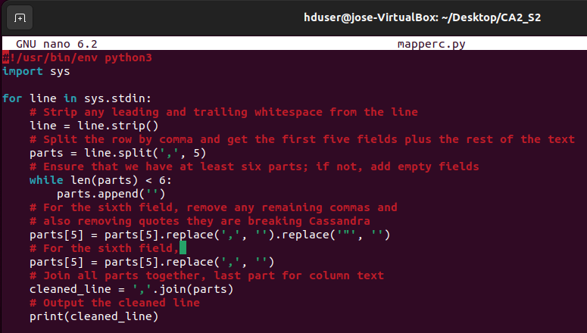  
Fig. 7. *mapperc.py*

The reducer merely passes the cleaned data through and saves it.

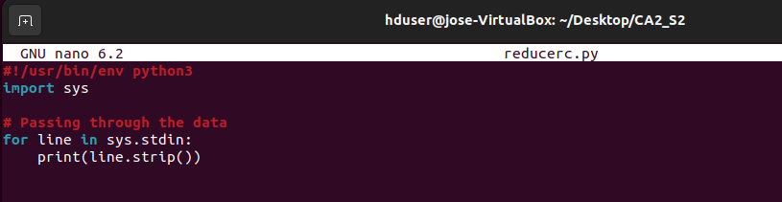  
Fig. 8. *reducerc.py*

# Ordering dataset based on *ids*

Above *MapReduce* output was not ordered by *ids. MapReduce* paradigm does not guarantee an ordered output.

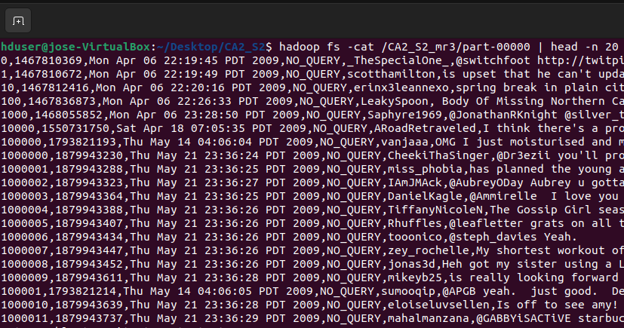  
Fig. 9. Cleaning tweets removing commas and quotes output.

This mapper transforms raw input into a structured key-value format, separating *ids* from the rest of the data.

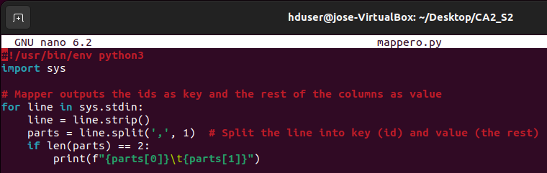  
Fig. 10. *mappero.py*

The reducer sorts the output by the key *ids.*

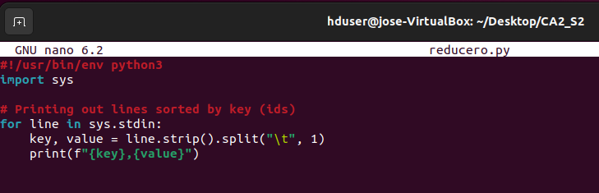  
Fig. 11. *reducero.py*

Having the data ordered is useful for *MySQL*, as this database inserts the data in the given order. In contrast, Cassandra, like *MapReduce*, does not input the data in an ordered manner due to its distributed nature. Both *MapReduce* and *Cassandra* are designed to handle large-scale data across distributed systems, which prioritize scalability and fault tolerance over maintaining data order. This distribution means that data is processed in parallel across multiple nodes, making the preservation of order less practical and often unnecessary for the intended analytical or transactional operations.

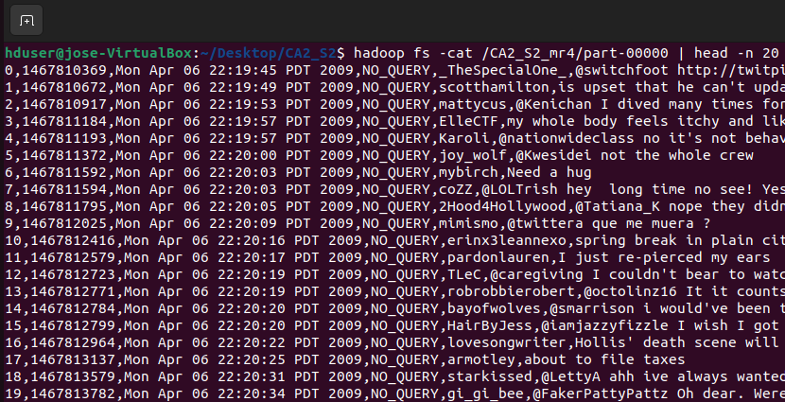  
Fig. 12. *MapReduce* output dataset ordered by *ids.*

# Spark

# Hive

*Facebook* engineers developed this technology in 2010 to simplify the complexity of writing *MapReduc*e jobs by utilizing *SQL* syntax. *Facebook's* analysts were familiar with *SQL,* which is why this querying language was used to extract information from its vast *Hadoop* datasets (Thusoo et al., 2010). Establishing an analogy the complexity of point *2.1.2.2. Distinct tweet_Id count* can be solved in just one line of code, *SELECT COUNT(DISTINCT tweet_id) FROM tweets;*

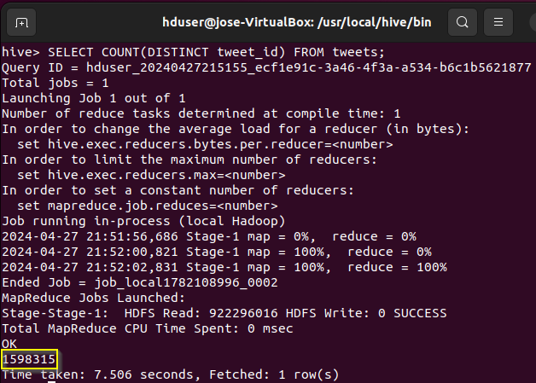

Fig. X. *Hive* output.

Both *MapReduce* and *Hive* yield the same outcome of 1,598,315 distinct t*weet_ids.* This is a simple and practical way of demonstrating why *Hive* was developed.

# *MySQL*

In section 2.2 a comparative database analysis for *MySQL* will be conducted. Prior to that, the output of the fourth *MapReduce* job (a dataset ordered by ID) was smoothly introduced into MySQL.

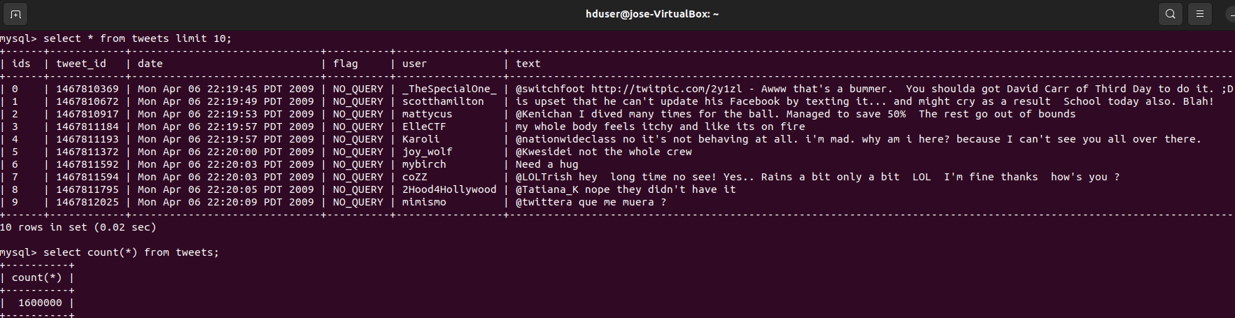Fig. X. *MySQL* queries.

One of the strong points of *MySQL* is its syntax, which is easy to interpret and perform.

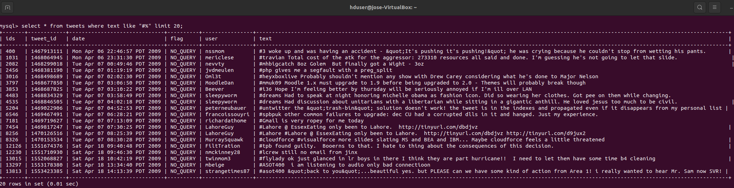  
Fig. X. *MySQL* query.

# Cassandra

Also, *Cassandra* will be evaluated in Section 2.2. Before that, the output from *MapReduce* job four was loaded. It is worth mentioning in this section the problems I encountered before concluding that *Cassandra* does not like commas prior to a data load; it was also skipping rows that contained quotes. In the screenshot below, the rows are not ordered by *ids*. This is because *Cassandra*, due to its distributed nature, does not concern itself with order but simply distributes the data across its nodes.

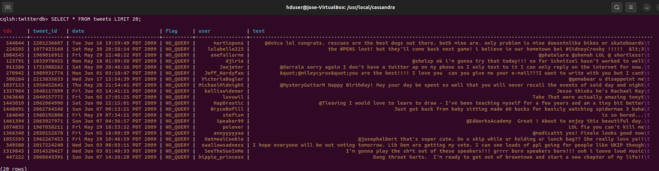  
Fig. X. *Cassandra* query first 20 rows.

# Database comparison for *Cassandra, MySQL* and *MongoDB* using YCSB.

Similarly to Brian F. Cooper, who published his paper on benchmarking databases (Cooper et al., 2010), this section will compare *Cassandra*, a distributed NoSQL database, *MySQL*, a relational database, and *MongoDB*, a document-oriented NoSQL database. All *YCSB* workloads, plus an additional one, Workload G, have been tested. Workload G (100% Write) serves to contrast with Workload C (100% Read). Note that Workload E has been modified from 95/05 to 65/35 scan/insert, because when running the tests initial outputs were not conclusive hence the change.  
The strategy for testing is based on five iterations, with changes in the number of rows inserted in each one. Full workload implementation can be seen in the annex sections 6.1.10, 6.1.11, and 6.1.12.

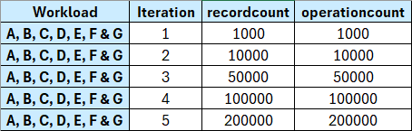  
Fig. X. *YCSB* Row load strategy.

# Workload A: Update heavy

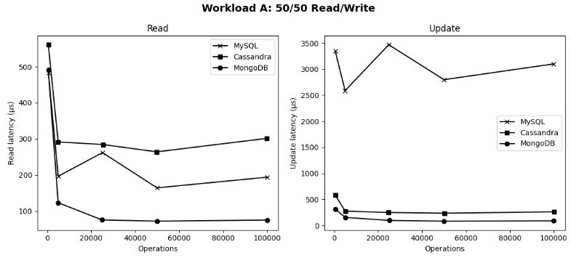  
Fig. X. Workload A.

# Workload B: Read mostly

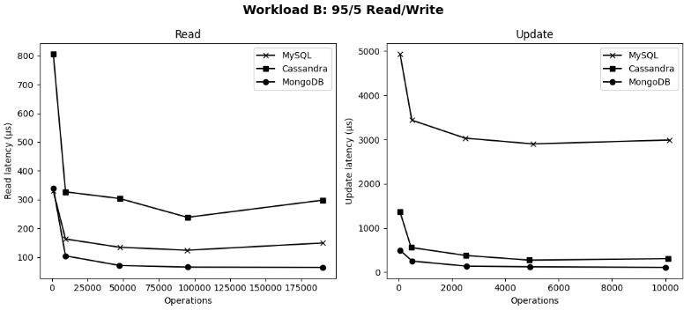  
Fig. X. Workload B.

# Workload C: Ready only

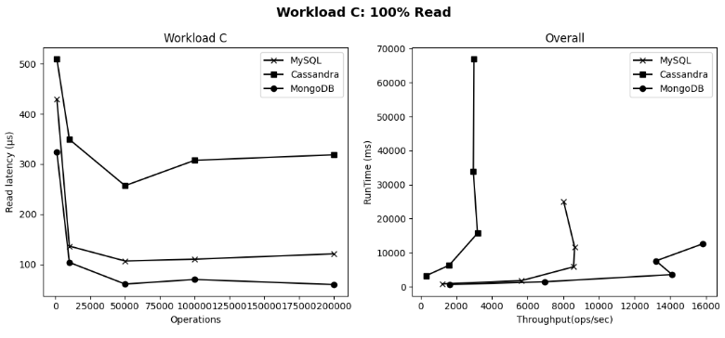  
Fig. X. Workload C.

# Workload D: Read latest

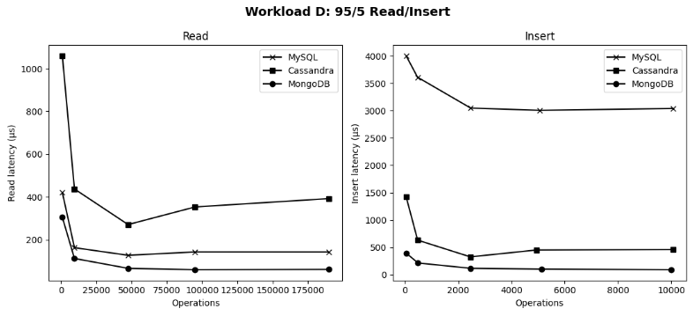  
Fig. X. Workload D.

# Workload E: Short ranges

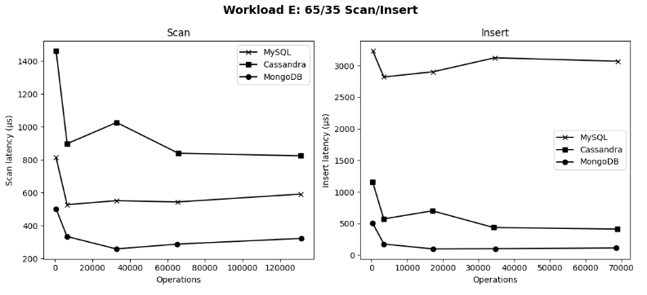  
Fig. X. Workload E.

# Workload F: Read-modify-write

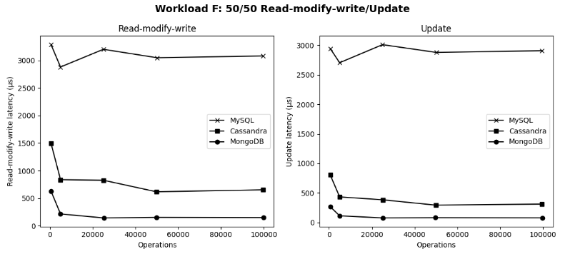  
Fig. X. Workload F.

# Workload G: Write only

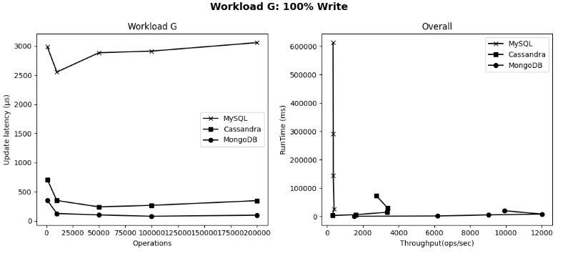  
Fig. X. Workload G.

# Rows load: inserts

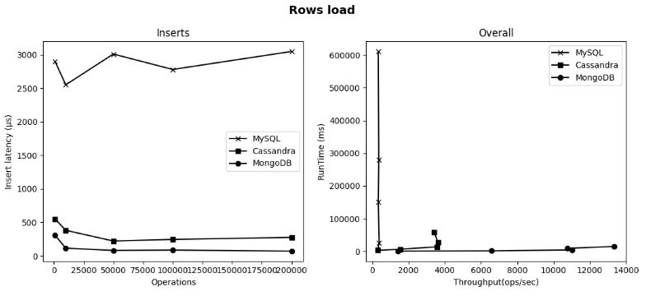  
Fig. X. Inserts.

# Conclusion

After the tests the conclusion is clear *MongoDB* is the best performer due to its document-oriented design, allows efficient retrieval and its BSON format enables quick scanning and indexing. *MySQL* is strong reading when workloads are balanced. *Cassandra* is designed for high write throughput and excels in writing scenarios.

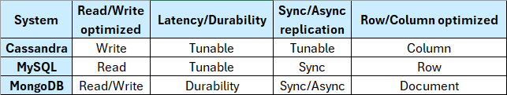  
Fig. X. Database characteristics.

  
Fig. X. Ranking performance.

# Rationale and justification for data processing, storage, and programming language

# Big Data diagram

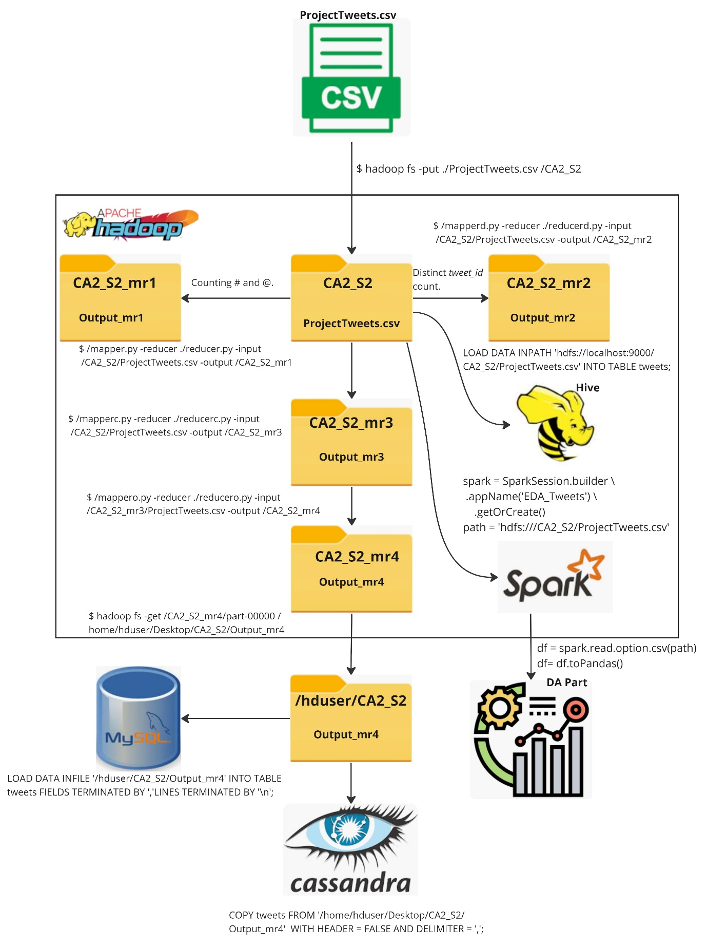

# **Advanced Data Analytics**

# DA

# **Conclusion**

# **References**

Cooper, B.F., Silberstein, A., Tam, E., Ramakrishnan, R. and Sears, R. (2010). Benchmarking cloud serving systems with YCSB. *Proceedings of the 1st ACM symposium on Cloud computing - SoCC ’10.* doi: https://doi.org/10.1145/1807128.1807152.

Manwal, M. and Gupta, A. (2017). Big data and hadoop — A technological survey, 2017 *International Conference on Emerging Trends in Computing and Communication Technologies (ICETCCT)*. DOI: 10.1109/ICETCCT.2017.8280345.

Thusoo, A., Shao, Z., Anthony, S., Borthakur, D., Jain, N., Sen Sarma, J., Murthy, R. and Liu, H. (2010). Data warehousing and analytics infrastructure at Facebook. *Proceedings of the 2010 ACM SIGMOD International Conference on Management of data*. doi: 10.1145/1807167.1807278.

# **Annex**

# Big Data

# Storing *ProjectTweets.csv* in HDFS

Initialize Hadoop and make sure is running:  
$ start-dfs.sh  
$ start-yarn.sh  
$ jps

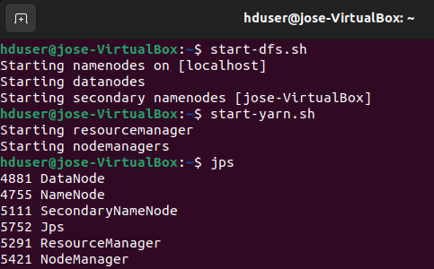

Locate *ProjectTweets.csv* usually it should be in Downloads:

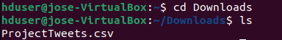

Before moving it into Hadoop a new directory for this file to be moved in must be created:  
$ Hadoop fs -mkdir /CA2_S2  
$ Hadoop fs -ls /

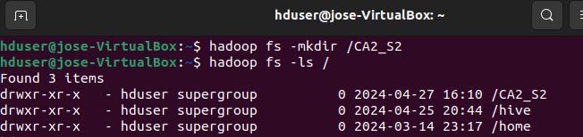

Moving the file into Hadoop:  
$ hadoop fs -put ./ProjectTweets.csv /CA2_S2

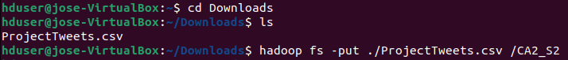

Listing the file into Hadoop directory CA2_S2:  
$ hadoop fs -ls /CA2_S2

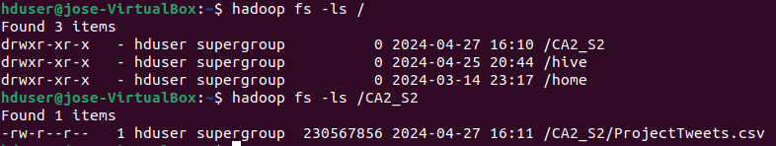

# *MapReduce* count and display mentions and hashtags

Before starting the mapper and reducer make sure permissions are granted:  
$ chmod 700 mapper.py  
$ chmod 700 reducer.py

Start the mapper.py and the reducer.py by typing this command:  
$ hadoop jar $HADOOP_HOME/share/hadoop/tools/lib/hadoop-streaming-3.3.6.jar -mapper ./mapper.py -reducer ./reducer.py -input /CA2_S2/ProjectTweets.csv -output /CA2_S2_mr1

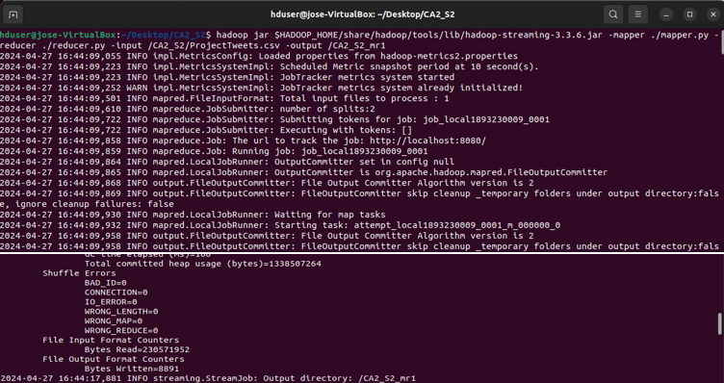

Output result it is printed in Hadoop directory CA2_S2_mr1:  
$ hadoop fs -cat /CA2_S2_mr1/part-00000

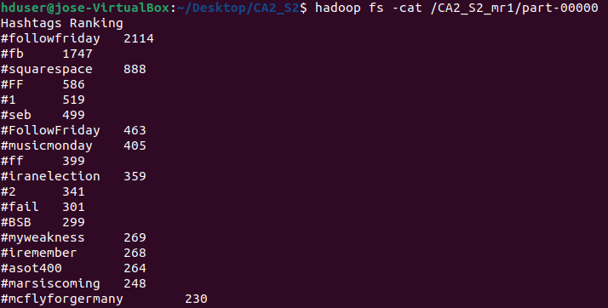

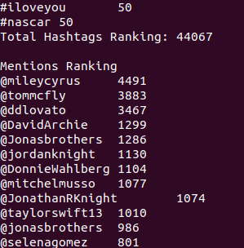

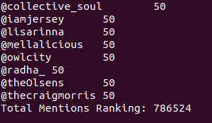

Move output to your local directory for readability:  
$ hadoop fs -cat /CA2_S2_mr1/part-00000 > /home/hduser/Desktop/CA2_S2/part-00000  
 $ mv /home/hduser/Desktop/CA2_S2/part-00000 /home/hduser/Desktop/CA2_S2/Output_mr1



# *MapReduce* distinct *tweet_id* count

Start *MapReduce* by typing the following command:  
$ hadoop jar $HADOOP_HOME/share/hadoop/tools/lib/hadoop-streaming-3.3.6.jar -mapper ./mapperd.py -reducer ./reducerd.py -input /CA2_S2/ProjectTweets.csv -output /CA2_S2_mr2

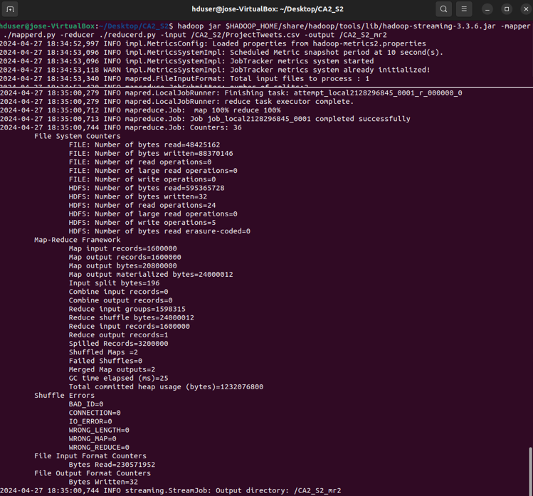

Displaying *MapReduce* result, moving it to a local folder and renaming it:  
$ hadoop fs -cat /CA2_S2_mr2/part-00000  
$ hadoop fs -cat /CA2_S2_mr2/part-00000 > /home/hduser/Desktop/CA2_S2/part-00000re  
$ mv /home/hduser/Desktop/CA2_S2/part-00000 /home/hduser/Desktop/CA2_S2/Output_mr2

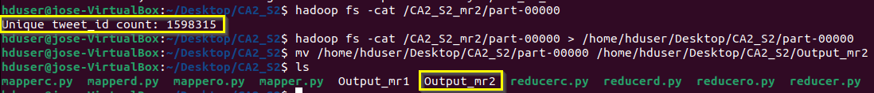

# *MapReduce* cleaning tweets removing commas and quotes

Start *MapReduce* by typing the following command:  
$ hadoop jar $HADOOP_HOME/share/hadoop/tools/lib/hadoop-streaming-3.3.6.jar -mapper ./mapperc.py -reducer ./reducerc.py -input /CA2_S2/ProjectTweets.csv -output /CA2_S2_mr3

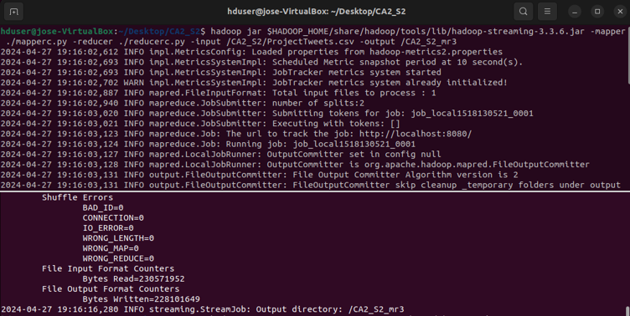

Displaying 20 rows to see if last column *text* has no commas and quotes:  
$ hadoop fs -cat /CA2_S2_mr3/part-00000 | head -n 20

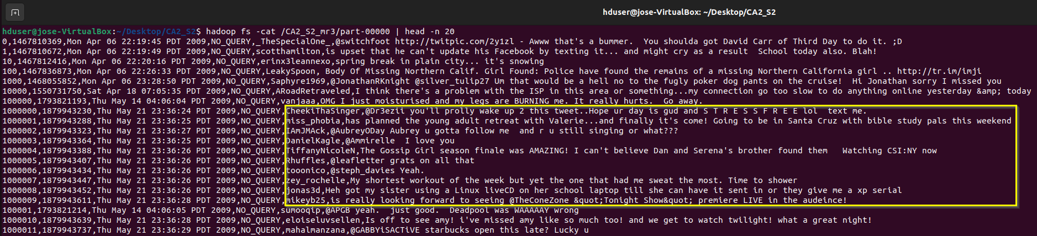

Moving output to local folder and renaming it:  
$ hadoop fs -get /CA2_S2_mr3/part-00000 /home/hduser/Desktop/CA2_S2/Output_mr3



# *MapReduce* ordering dataset based on *ids*

Start *MapReduce* by typing the following command:  
$ hadoop jar $HADOOP_HOME/share/hadoop/tools/lib/hadoop-streaming-3.3.6.jar \

-D mapreduce.job.output.key.comparator.class=org.apache.hadoop.mapred.lib.KeyFieldBasedComparator \  
 -D stream.num.map.output.key.fields=2 \  
 -D mapreduce.map.output.key.field.separator=, \  
 -D mapreduce.partition.keycomparator.options="-k1,1n" \  
 -files ./mappero.py,./reducero.py \  
 -mapper mappero.py \  
 -reducer reducero.py \  
 -input /CA2_S2_mr3/part-00000 \  
 -output /CA2_S2_mr4

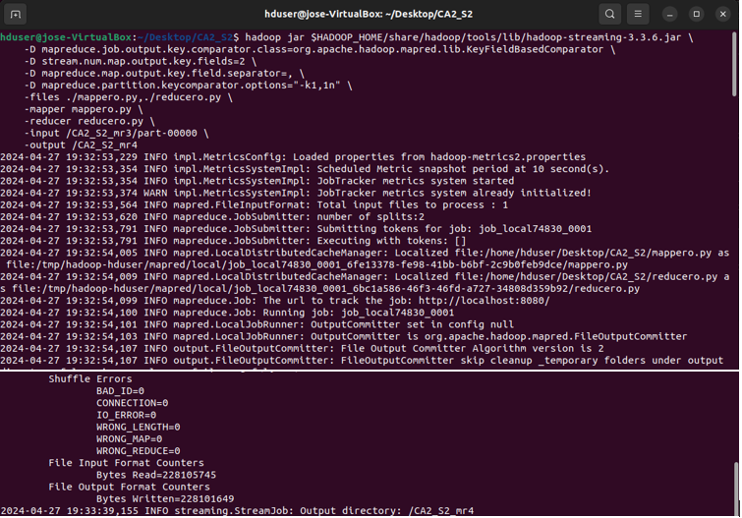

Displaying 20 rows to see if rows are displaying in ascending order:  
$ hadoop fs -cat /CA2_S2_mr4/part-00000 | head -n 20

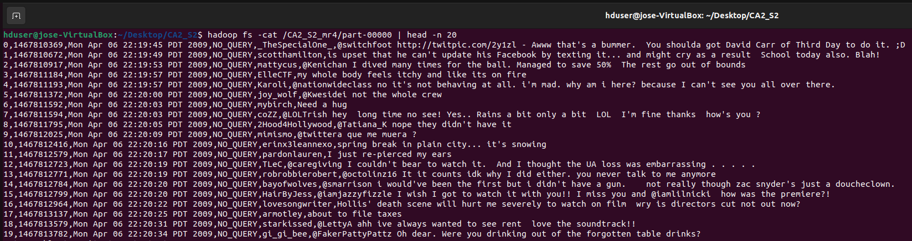

Moving output to local folder and renaming it:  
$ hadoop fs -get /CA2_S2_mr4/part-00000 /home/hduser/Desktop/CA2_S2/Output_mr4

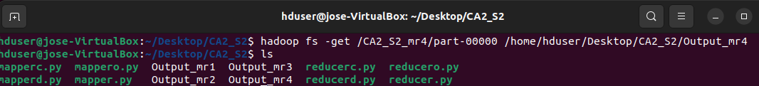

# *Spark*

Locate ProjectTweets.csv usually it should in Downloads:

# *Hive*

To run *Hive* first start *Hadoop* and right after activate *Hive* bash:  
$ start-dfs.sh  
$ start-yarn.sh  
$ cd /usr/local/hive/bin  
$ hive

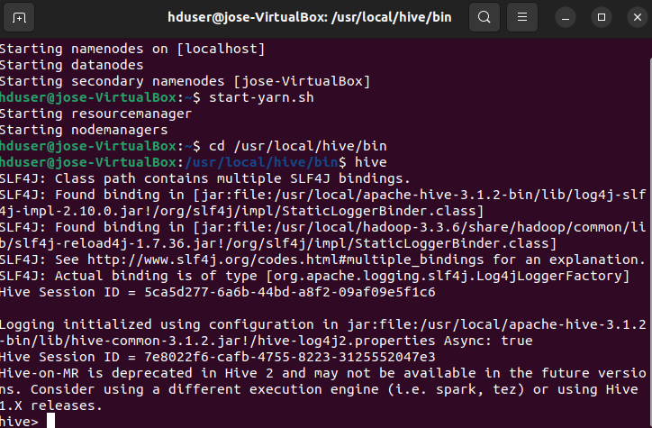

Table creation *tweets* and data load:  
CREATE TABLE tweets (ids STRING, tweet_id STRING, `date` STRING, flag STRING, `user` STRING, `text` STRING) ROW FORMAT DELIMITED FIELDS TERMINATED BY '\054';  
LOAD DATA INPATH 'hdfs://localhost:9000/CA2_S2/ProjectTweets.csv' INTO TABLE tweets;



Select first 10 rows to see table structure and also make sure that the 1,600,000 went through:  
select * from tweets limit 10;  
select count(*) from tweets;

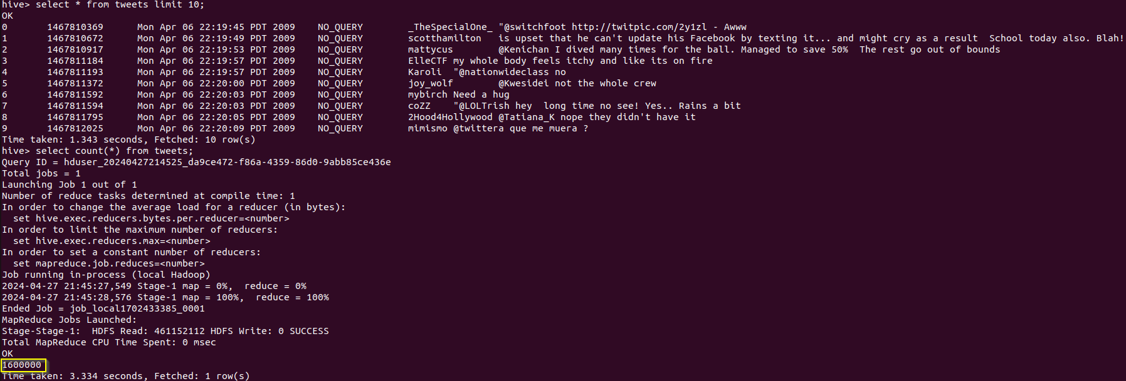

Counting distinct rows from *tweet_id:*  
SELECT COUNT(DISTINCT tweet_id) FROM tweets;



# *MySQL*

Connect to *MySQL,* create *twitterdb,* use this database, create table *tweets,* load the data and retrieve fist 10 rows:  
create database twitterdb;  
use twitterdb;  
CREATE TABLE tweets (ids text,tweet_id text,`date` VARCHAR(255),flag VARCHAR(255),`user` VARCHAR(255),`text` text);  
LOAD DATA INFILE '/var/lib/mysql-files/Output_mr4' INTO TABLE tweets FIELDS TERMINATED BY ',' LINES TERMINATED BY '\n' (ids, tweet_id, date, flag, user, text);

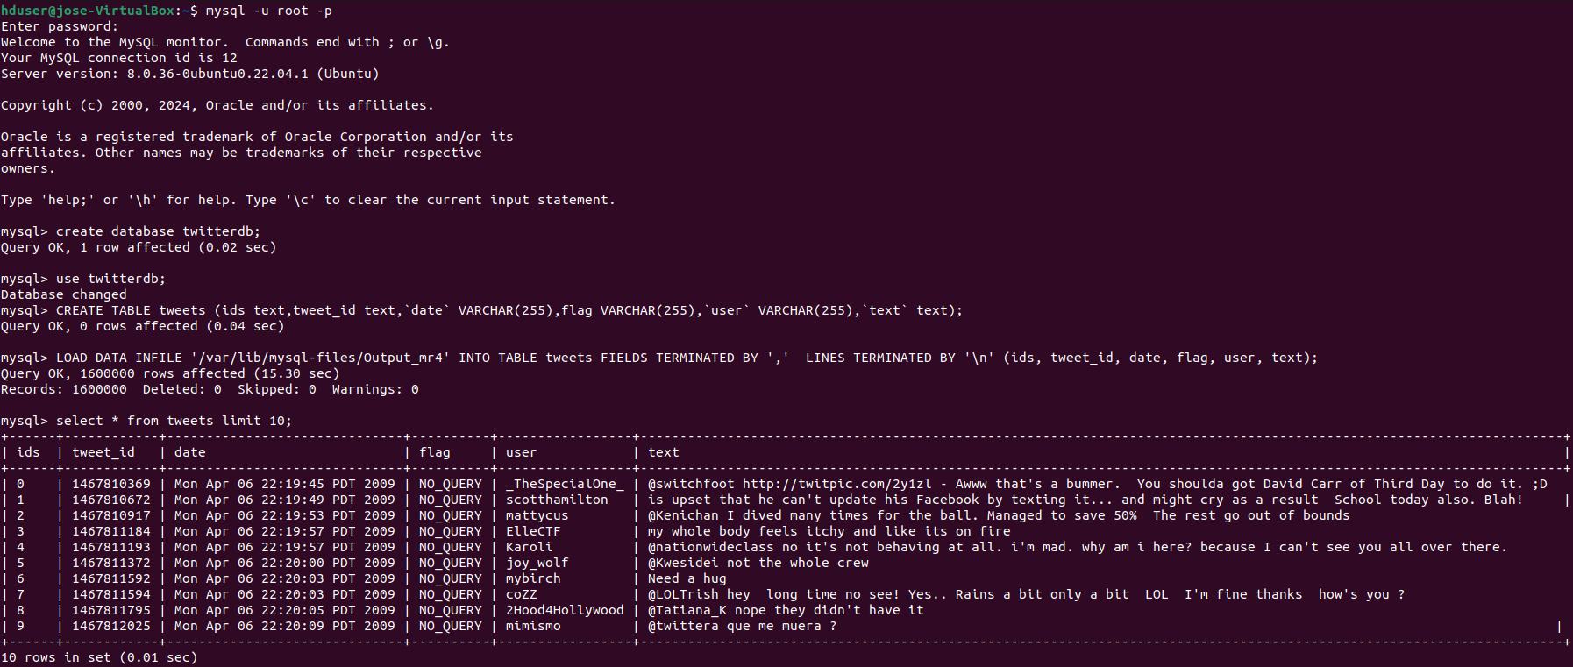

Before loading the data, *Output_mr4* has to be copied into *mysql-files:*sudo cp /home/hduser/Desktop/CA2_S2/Output_mr4 /var/lib/mysql-files/

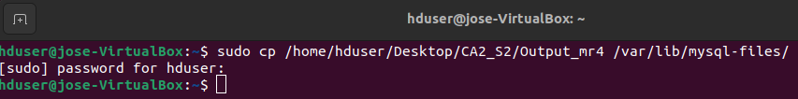

# *Cassandra*

To initialize it insert:  
$ cd /usr/local/cassandra/  
$ bin/cassandra -f

Right after in a different terminal type:  
$ cd /usr/local/cassandra/  
$ bin/cqlsh

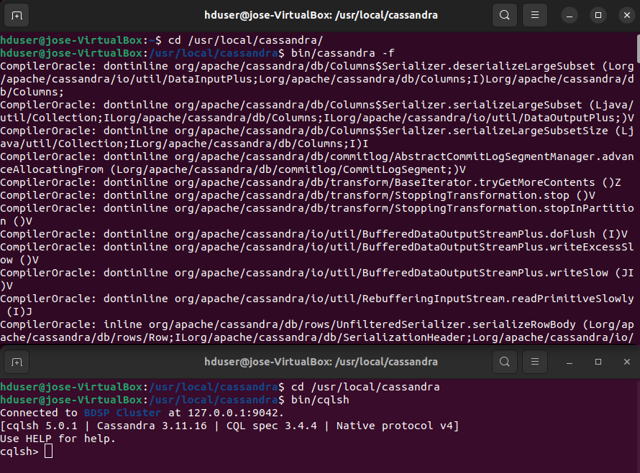

Once in *Cassandra* bash type the following to insert *MapReduce* four output:  
DESCRIBE KEYSPACES;  
CREATE KEYSPACE twitterdb WITH REPLICATION = { 'class' : 'SimpleStrategy', 'replication_factor' : 1 };  
use twitterdb;  
CREATE TABLE tweets(ids text, tweet_id text, date text, flag text, user text, text text, primary key (ids, tweet_id, date, flag, user, text));  
COPY tweets FROM '/home/hduser/Desktop/CA2_S2/Output_mr4' WITH HEADER = FALSE AND DELIMITER = ',';

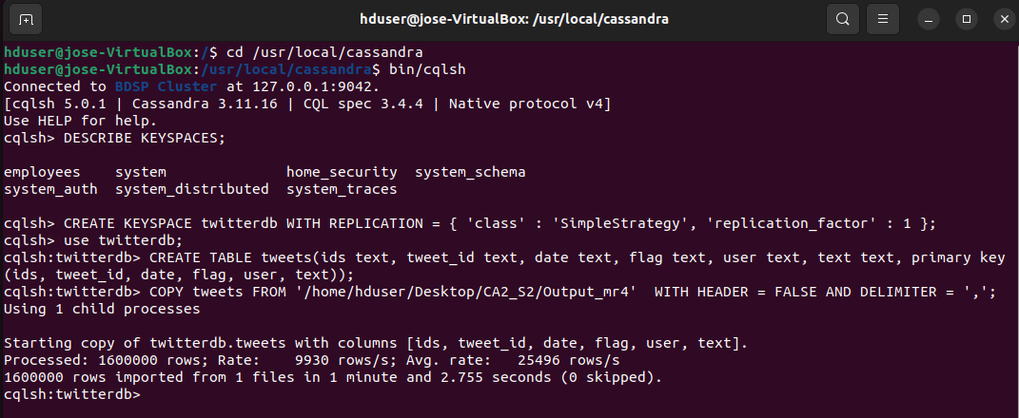

Display first 20 rows:  
SELECT * FROM tweets LIMIT 20;



# *YCSB: MySQL*

Fist we need to create a database and a table in order to load rows and perform the tests, start your mysql:  
mysql -u root -p  
create database BenchTest;  
use BenchTest;  
CREATE TABLE usertable (YCSB_KEY VARCHAR(255) PRIMARY KEY,  
FIELD0 VARCHAR(255), FIELD1 VARCHAR(255),  
FIELD2 VARCHAR(255), FIELD3 VARCHAR(255),  
FIELD4 VARCHAR(255), FIELD5 VARCHAR(255),  
FIELD6 VARCHAR(255), FIELD7 VARCHAR(255),  
FIELD8 VARCHAR(255), FIELD9 VARCHAR(255));

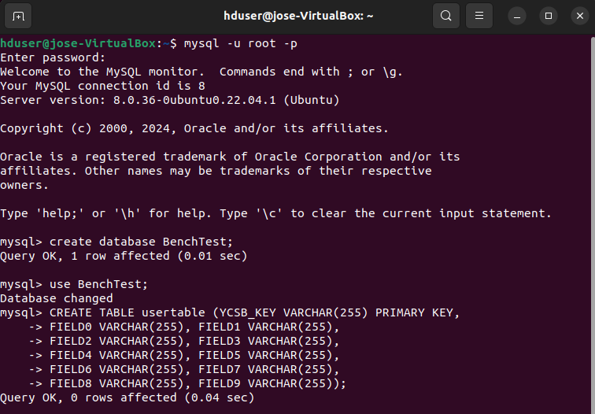

Open a new terminal and go to *ycsb* directory, display all workloads:  
$ cd /home/hduser/ycsb-0.17.0  
$ cd workloads  
$ ls

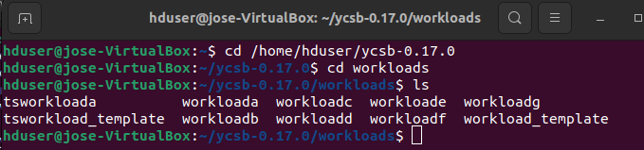

Before running the workloads, ensure that the fields *recordcount* and *operationcount* have the same number. To carry out the tests, five iterations will be done, changing these values from 1,000 to 10,000, 50,000, 100,000, and 200,000. Ultimately, for each iteration, these rows will be inserted into MySQL. Remember that between iterations, lines should be deleted; otherwise, new lines cannot be inserted. Let us see the steps:  
$ nano workloada  
$ nano workloadb  
$ nano workloadc  
$ nano workloadd  
$ nano workloade  
$ nano workloadf  
$ nano workloadg

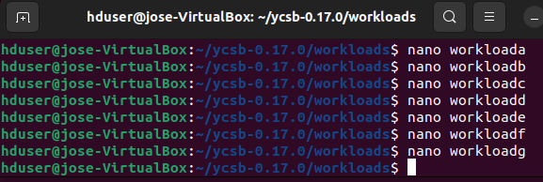

Remember for each iteration to make sure that lines match:

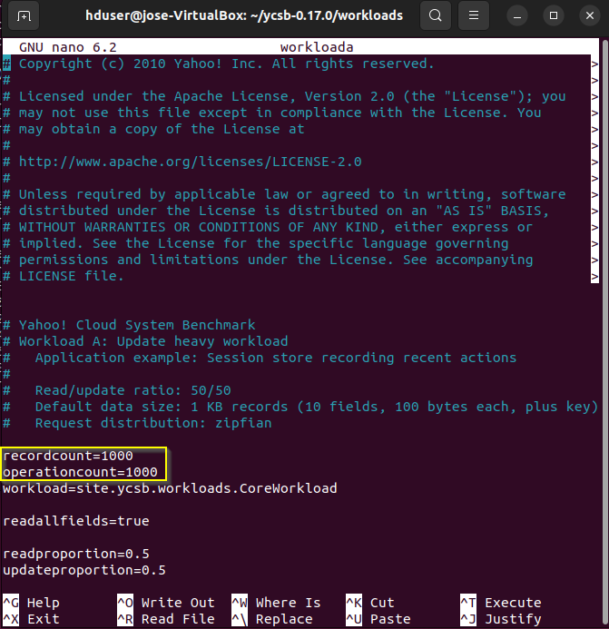

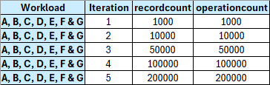

Once workloads are adjusted, rows must be loaded into previously created table *username* by running the following commands:  
$ cd ..  
$ ./bin/ycsb.sh load jdbc -P ./jdbc-binding/conf/db.properties -P workloads/workloada

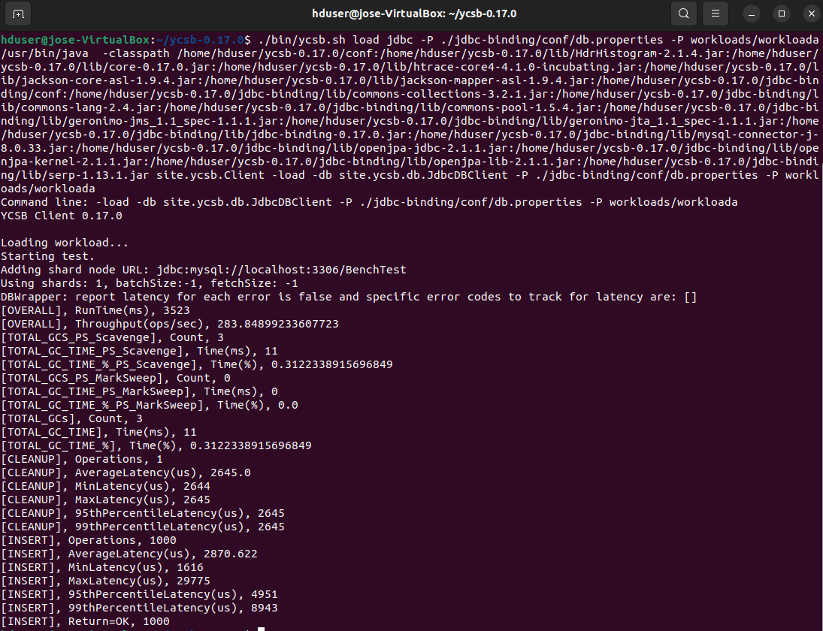

Now go back to *MySQL* and see what *ycsb* has inserted into *usertable:*select * from usertable limit 5;  
select count(*) from usertable;

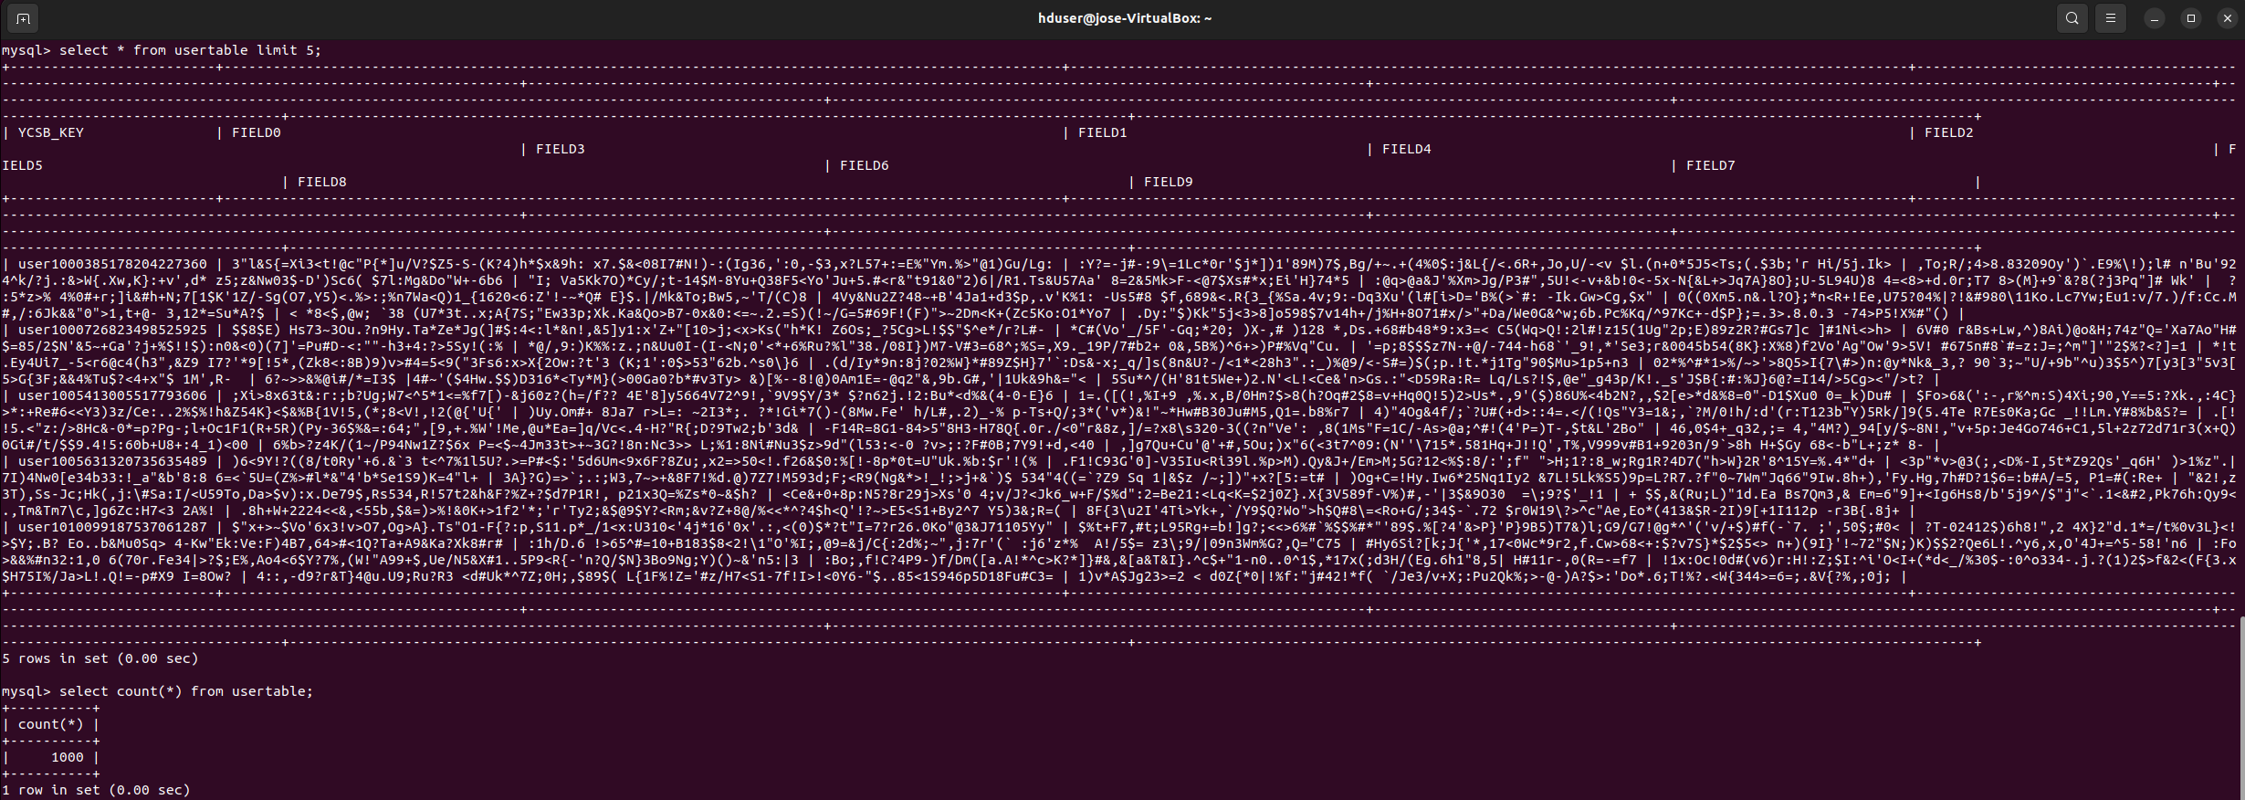

Random characters allocated for testing—1,000 set in Workload A—are inserted; now we can start running the workloads. For practicality, I will be running Workload A next. The subsequent workloads are the same; please adjust accordingly:  
$ ./bin/ycsb.sh run jdbc -P workloads/workloada -P ./jdbc-binding/conf/db.properties

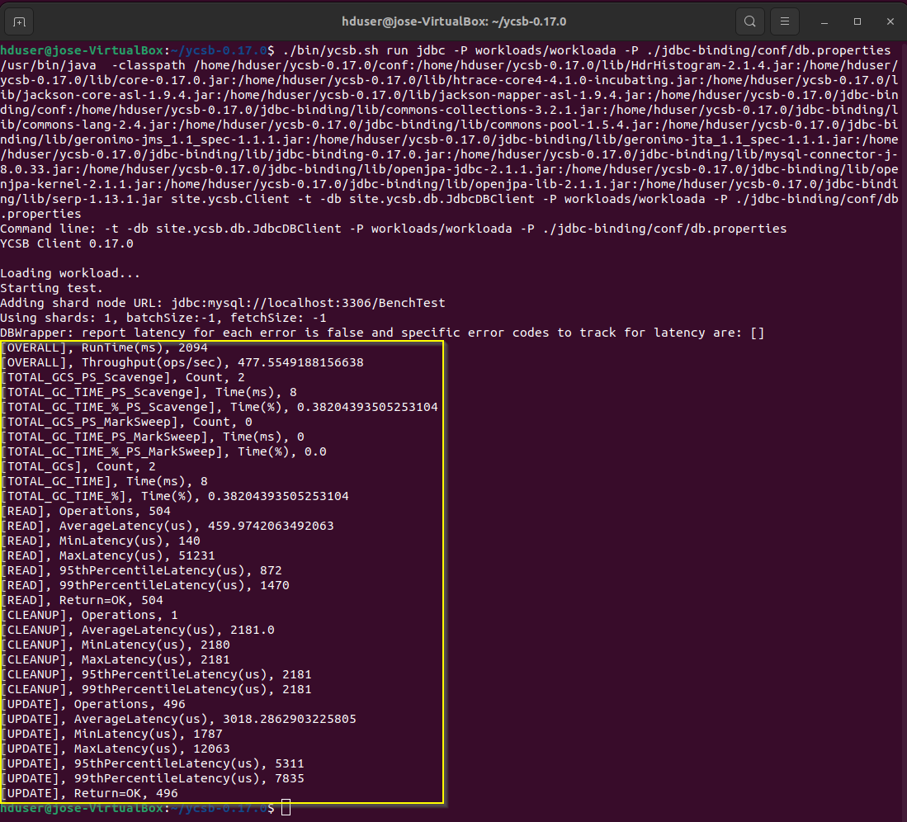

The highlighted output is key to comparing workload performance across databases. Ensure you copy it to plot later. The rest of the commands for the workloads are as follows:  
$ ./bin/ycsb.sh run jdbc -P workloads/workloadb -P ./jdbc-binding/conf/db.properties  
$ ./bin/ycsb.sh run jdbc -P workloads/workloadc -P ./jdbc-binding/conf/db.properties  
$ ./bin/ycsb.sh run jdbc -P workloads/workloadd -P ./jdbc-binding/conf/db.properties  
$ ./bin/ycsb.sh run jdbc -P workloads/workloade -P ./jdbc-binding/conf/db.properties  
$ ./bin/ycsb.sh run jdbc -P workloads/workloadf -P ./jdbc-binding/conf/db.properties  
$ ./bin/ycsb.sh run jdbc -P workloads/workloadg -P ./jdbc-binding/conf/db.properties

# *YCSB: MongoDB*

Open a new terminal and type the following, let this terminal running alone:  
$ mongod --bind_ip 127.0.0.1

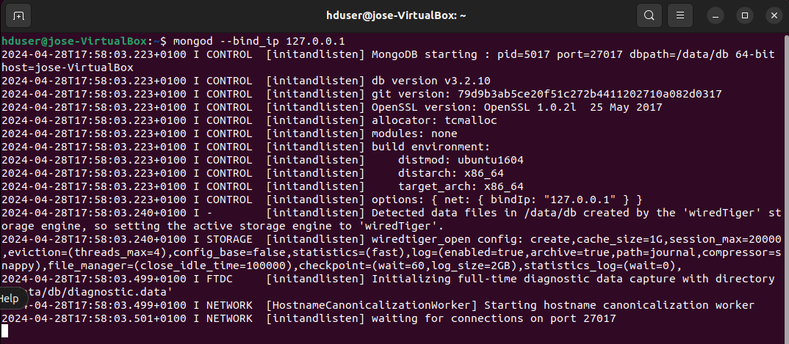

Open a new terminal and go to ycsb directory, display all workloads:  
$ cd /home/hduser/ycsb-0.17.0  
$ cd workloads  
$ ls



Before running the workloads, ensure that the fields *recordcount* and *operationcount* have the same number. To carry out the tests, five iterations will be done, changing these values from 1,000 to 10,000, 50,000, 100,000, and 200,000. Ultimately, for each iteration, these rows will be inserted into MySQL. Remember that between iterations, lines should be deleted; otherwise, new lines cannot be inserted. Let us see the steps:  
$ nano workloada  
$ nano workloadb  
$ nano workloadc  
$ nano workloadd  
$ nano workloade  
$ nano workloadf  
$ nano workloadg



Remember for each iteration to make sure that lines match:





Once workloads are adjusted, rows must be loaded into previously created table *username* by running the following commands:  
$ cd ..  
$ ./bin/ycsb.sh load mongodb -s -P workloads/workloada

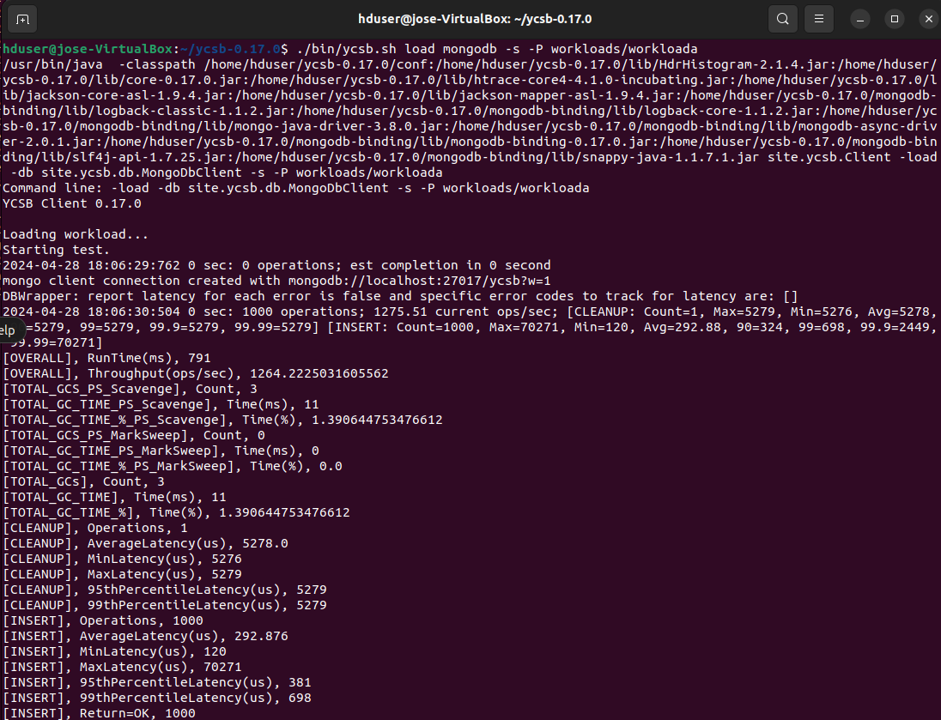

Please notice that for *MongoDB* it was no need to create a database or table, it all was done by *ycsb*, looking into *MongoDB* for the lines inserted:  
mongo  
use ycsb  
db.usertable.count()  
db.usertable.find().count()

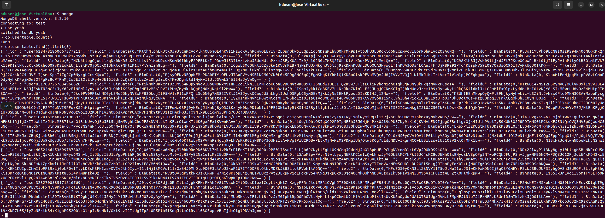

Random characters allocated for testing—1,000 set in Workload A—are inserted; now we can start running the workloads. For practicality, I will be running Workload A next. The subsequent workloads are the same; please adjust accordingly:  
$ ./bin/ycsb.sh run mongodb -s -P workloads/workloada

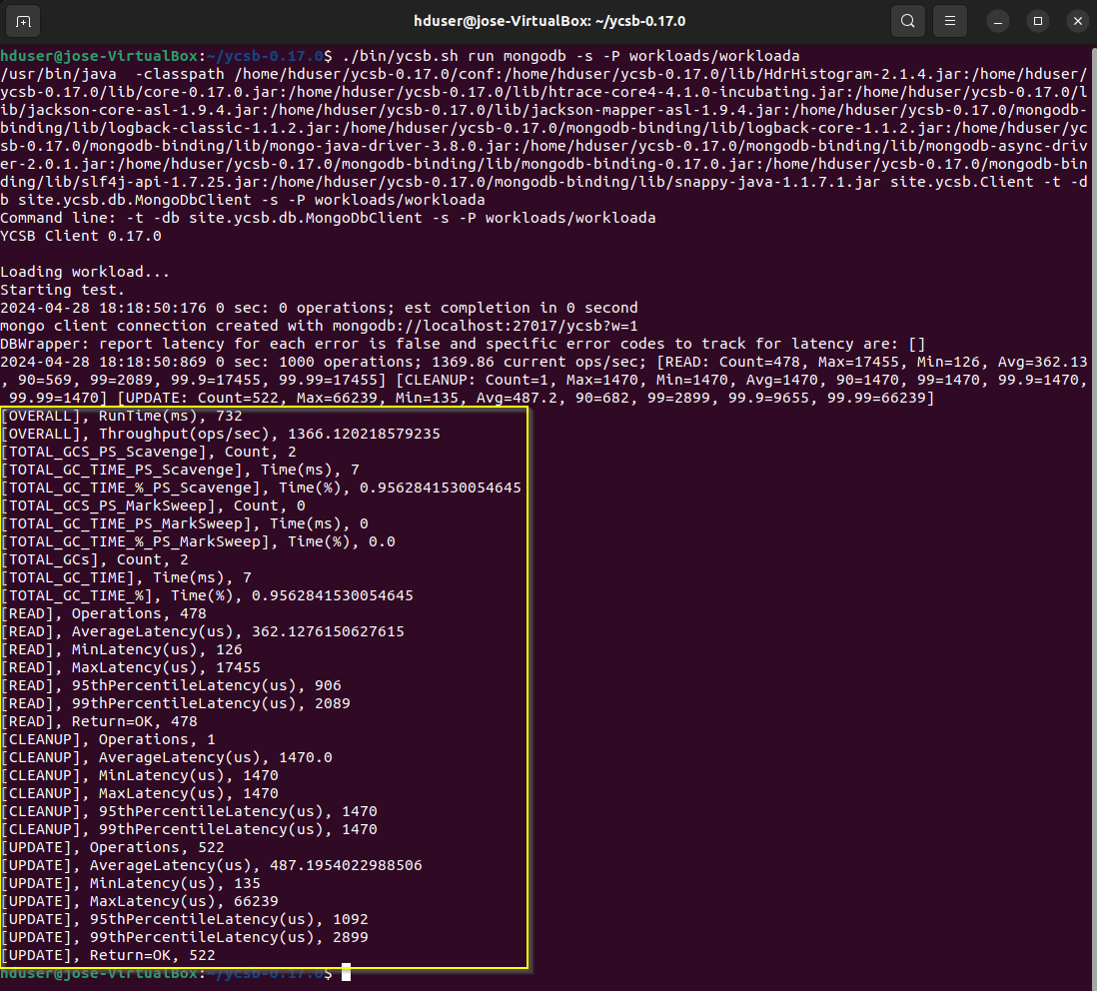

The highlighted output is key to comparing workload performance across databases. Ensure you copy it to plot later. The rest of the commands for the workloads are as follows:  
$ ./bin/ycsb.sh run mongodb -s -P workloads/workloadb  
$ ./bin/ycsb.sh run mongodb -s -P workloads/workloadc  
$ ./bin/ycsb.sh run mongodb -s -P workloads/workloadd  
$ ./bin/ycsb.sh run mongodb -s -P workloads/workloade  
$ ./bin/ycsb.sh run mongodb -s -P workloads/workloadf  
$ ./bin/ycsb.sh run mongodb -s -P workloads/workloadg

# *YCSB: Cassandra*

Open up *Cassandra* as usual and let it run in a separate console:  
$ cd /usr/local/cassandra/  
$ bin/cassandra -f

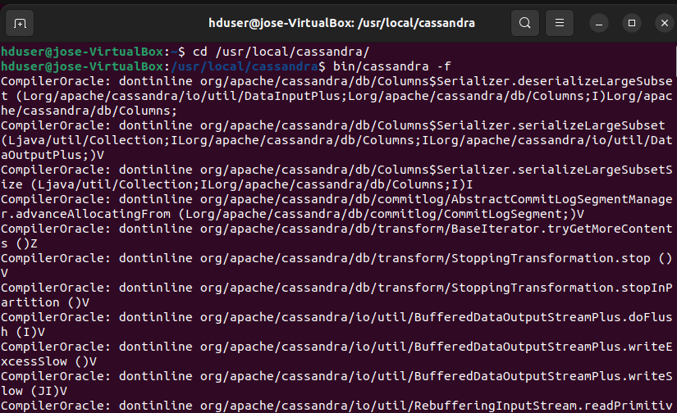

Open a new terminal and go to *Cassandra* bash, a new kesypace called *ycsb* and a table *usertable:*  
$ cd /usr/local/cassandra  
$ bin/cqlsh  
create keyspace ycsb WITH REPLICATION = {'class' : 'SimpleStrategy', 'replication_factor': 3 };  
USE ycsb;  
create table usertable (y_id varchar primary key,field0 varchar,field1 varchar,field2 varchar,field3 varchar,field4 varchar,field5 varchar,field6 varchar,field7 varchar,field8 varchar,field9 varchar);

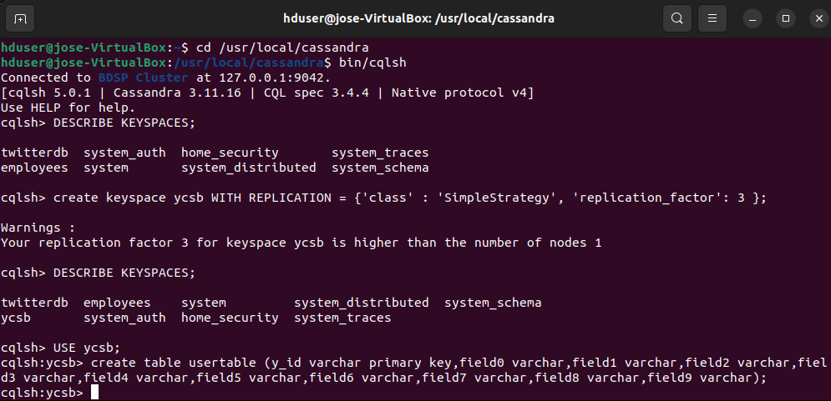

Open a new terminal and go to ycsb directory, display all workloads:  
$ cd /home/hduser/ycsb-0.17.0  
$ cd workloads  
$ ls



Before running the workloads, ensure that the fields *recordcount* and *operationcount* have the same number. To carry out the tests, five iterations will be done, changing these values from 1,000 to 10,000, 50,000, 100,000, and 200,000. Ultimately, for each iteration, these rows will be inserted into MySQL. Remember that between iterations, lines should be deleted; otherwise, new lines cannot be inserted. Let us see the steps:  
$ nano workloada  
$ nano workloadb  
$ nano workloadc  
$ nano workloadd  
$ nano workloade  
$ nano workloadf  
$ nano workloadg



Remember for each iteration to make sure that lines match:





Once workloads are adjusted, rows must be loaded into previously created table *username* by running the following commands:  
$ cd ..  
$ ./bin/ycsb.sh load cassandra-cql -p hosts=10.0.2.15,127.0.0.1 -p port=9042 -p debug=true -P workloads/workloada -s

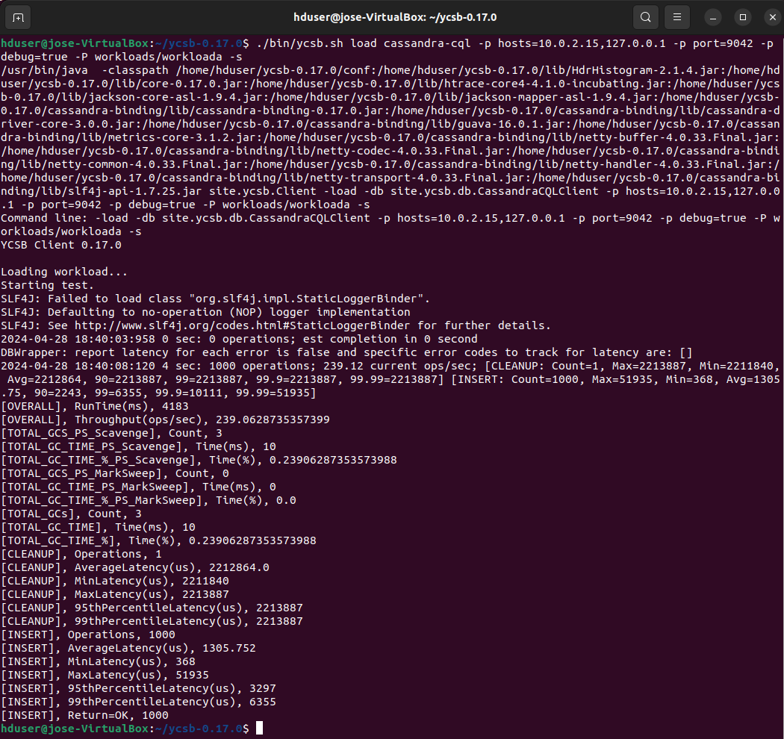

Now go back to *Cassandra* and see what *ycsb* has inserted into *usertable:*select count(*) from usertable;  
select * from usertable limit 5;

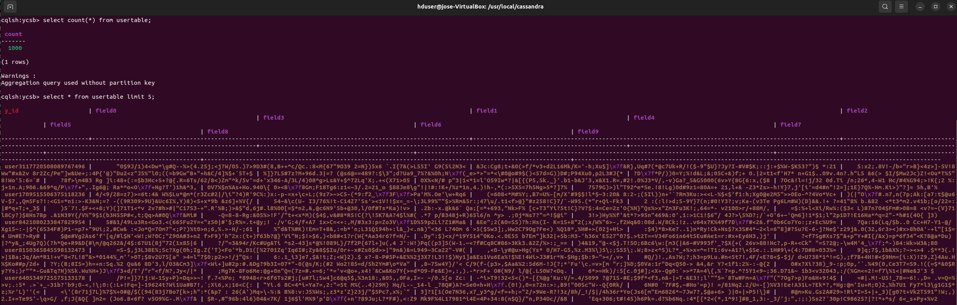

Random characters allocated for testing—1,000 set in Workload A—are inserted; now we can start running the workloads. For practicality, I will be running Workload A next. The subsequent workloads are the same; please adjust accordingly:  
$ ./bin/ycsb.sh run cassandra-cql -p hosts=10.0.2.15,127.0.0.1 -p port=9042 -p debug=true -P workloads/workloada -s

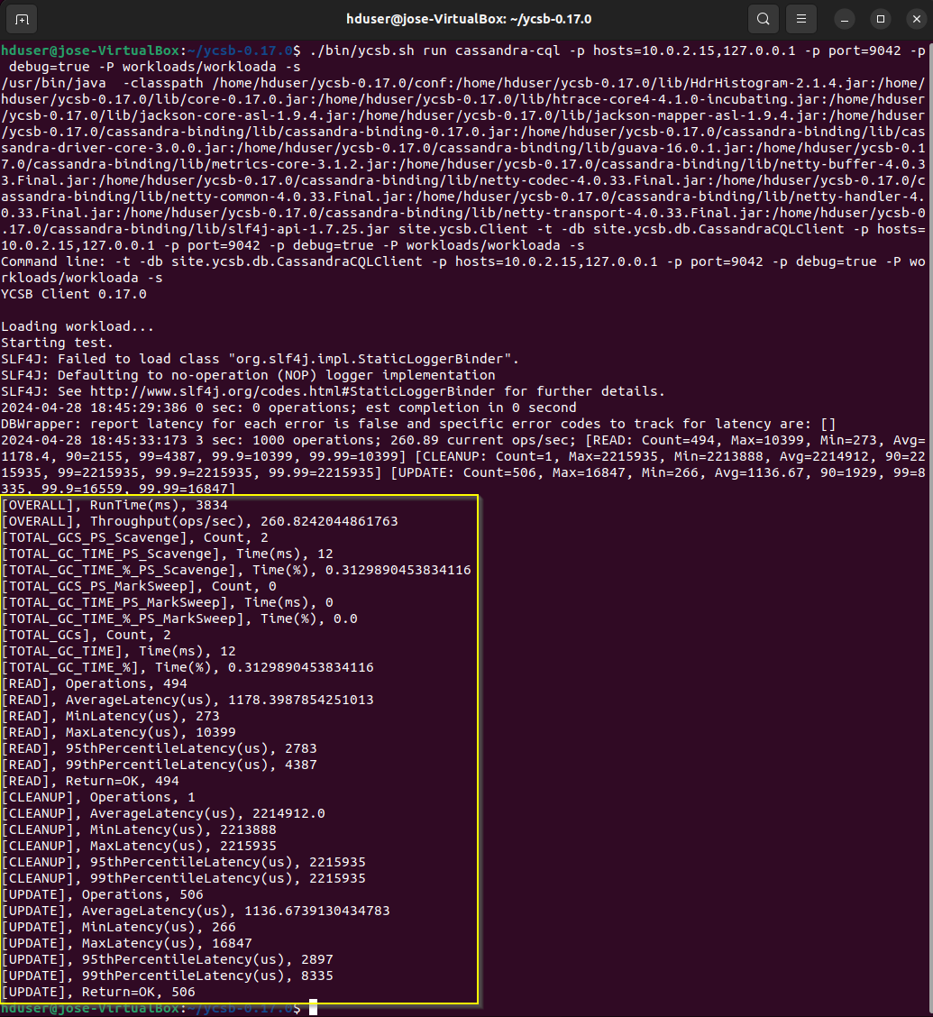

The highlighted output is key to comparing workload performance across databases. Ensure you copy it to plot later. The rest of the commands for the workloads are as follows:  
$ ./bin/ycsb.sh run cassandra-cql -p hosts=10.0.2.15,127.0.0.1 -p port=9042 -p debug=true -P workloads/workloadb -s  
$ ./bin/ycsb.sh run cassandra-cql -p hosts=10.0.2.15,127.0.0.1 -p port=9042 -p debug=true -P workloads/workloadc -s   
$ ./bin/ycsb.sh run cassandra-cql -p hosts=10.0.2.15,127.0.0.1 -p port=9042 -p debug=true -P workloads/workloadd -s   
$ ./bin/ycsb.sh run cassandra-cql -p hosts=10.0.2.15,127.0.0.1 -p port=9042 -p debug=true -P workloads/workloadd -s   
$ ./bin/ycsb.sh run cassandra-cql -p hosts=10.0.2.15,127.0.0.1 -p port=9042 -p debug=true -P workloads/workloadf -s   
$ ./bin/ycsb.sh run cassandra-cql -p hosts=10.0.2.15,127.0.0.1 -p port=9042 -p debug=true -P workloads/workloadg -s

It is important to note that all workloads outputs can be seen in *YCSB_Workload_Outputs.txt*. For a visual understanding, these results are also plotted in the Jupyter Notebook *YCSB_Workloads_Graphs.ipynb*